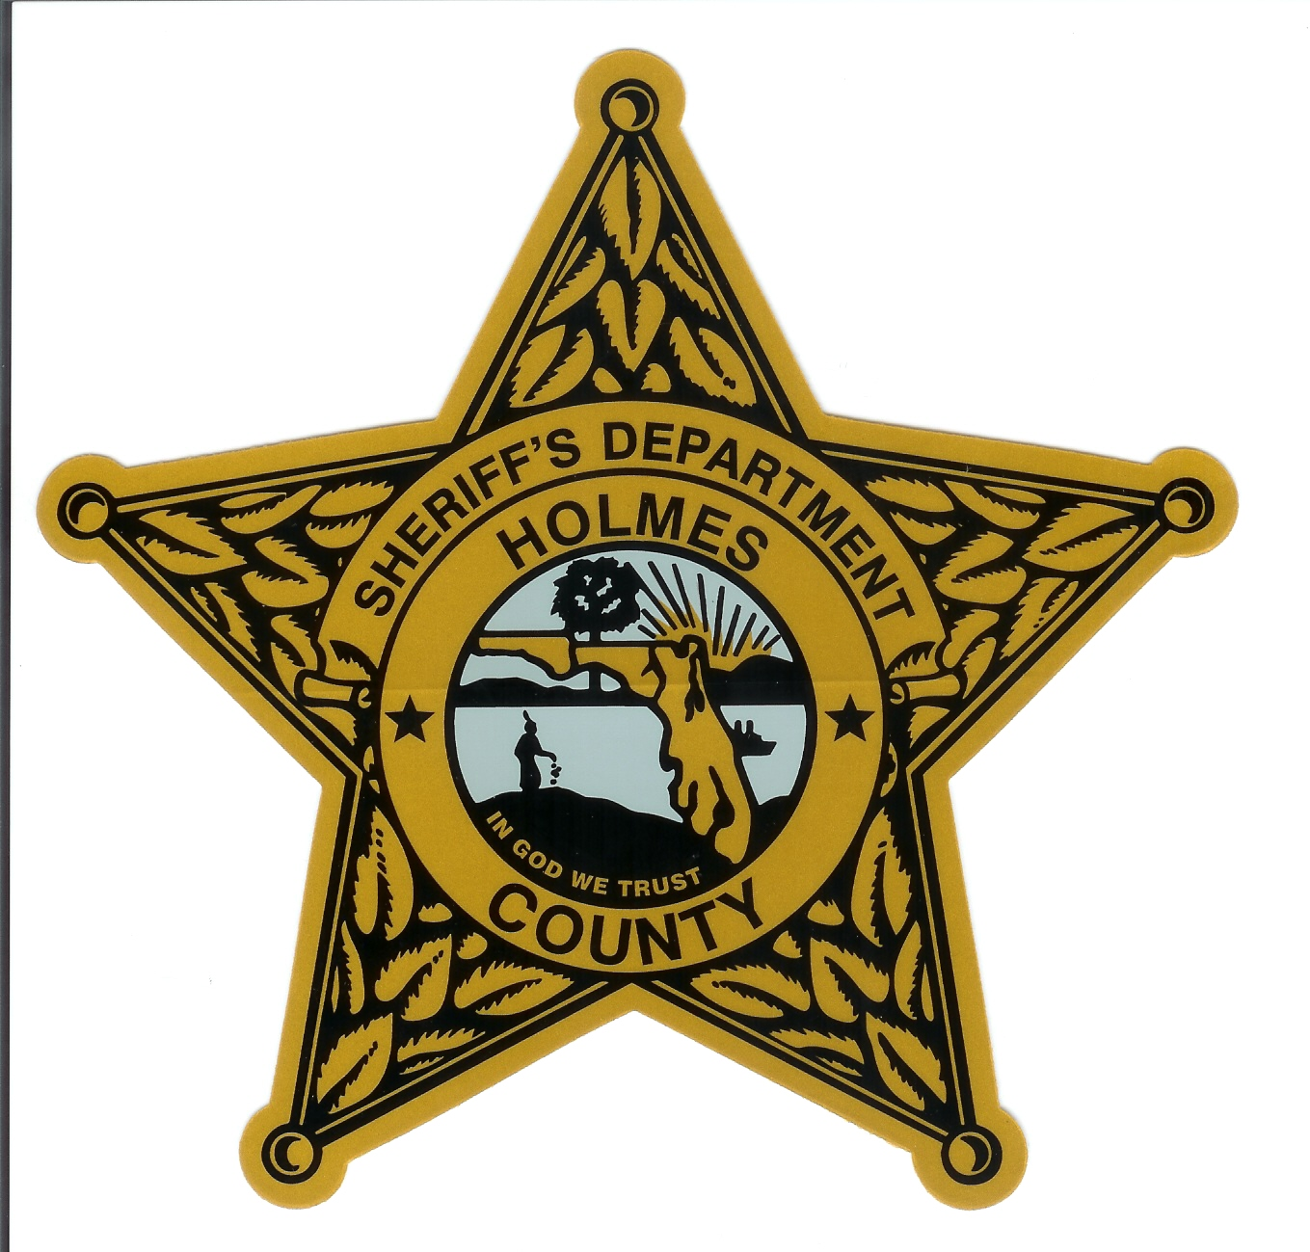
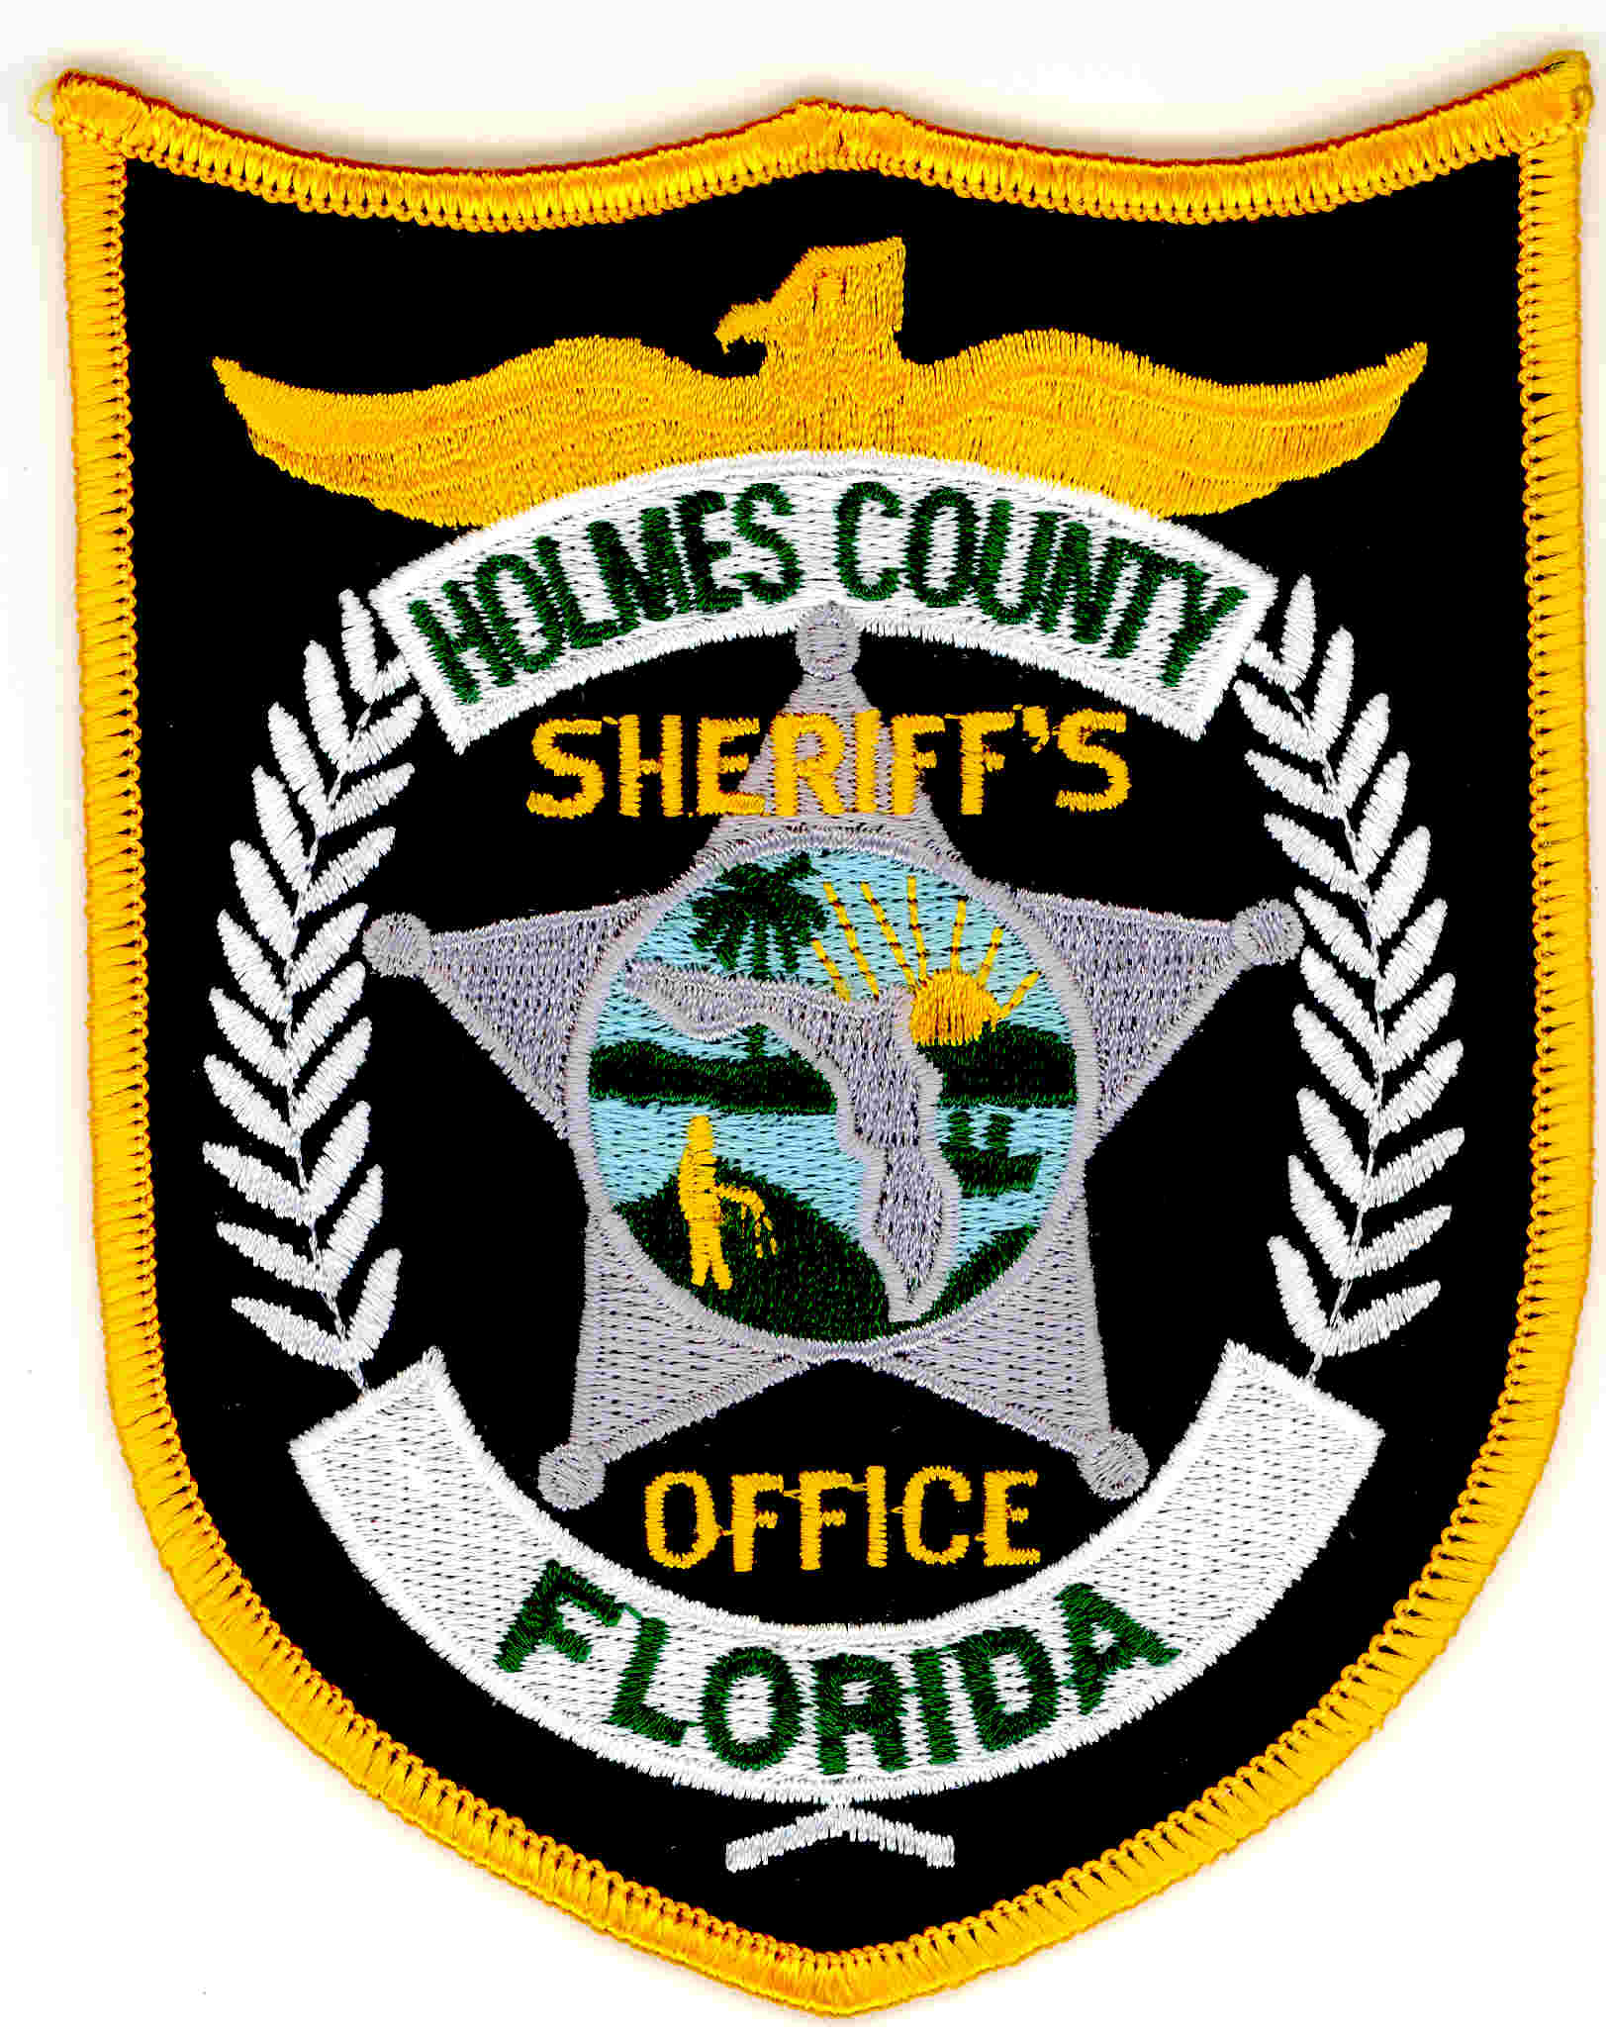
Holmes County Sheriff’s Office
Tim Brown, Sheriff
211 North Oklahoma Street
Bonifay, FL 32425
(850) 547-3681

PRESS RELEASE

On January 20, 2015, a Deputy with the Holmes County Sheriff’s Office attempted to initiate a traffic stop involving a motorcycle, near Hwy 2 and 179A. The motorcycle, occupied by John C Lewis JR of Bonifay, fled law enforcement and eventually crashed in Geneva County Alabama. Lewis was transported to an area hospital for treatment with charges pending. The Holmes County Sheriff’s Office would like to thank Geneva Police Department for the assistance they provided in this case.

